Gravitational Potential Energy

Work Done Against Gravity

Let’s calculate the work done in lifting an object of mass m through a height h, if the object is lifted
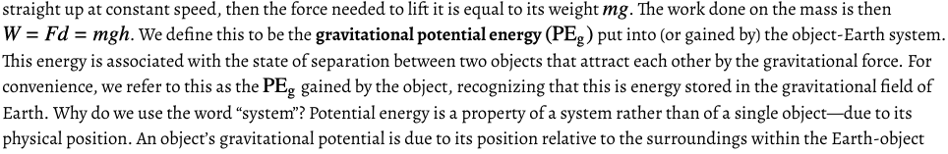
System.

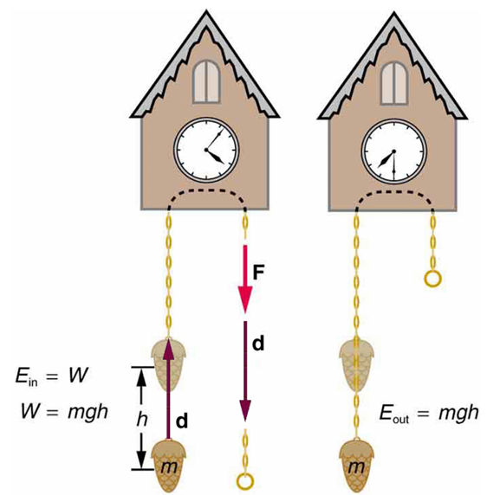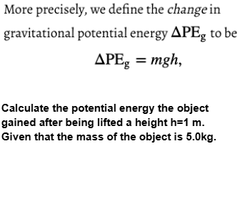
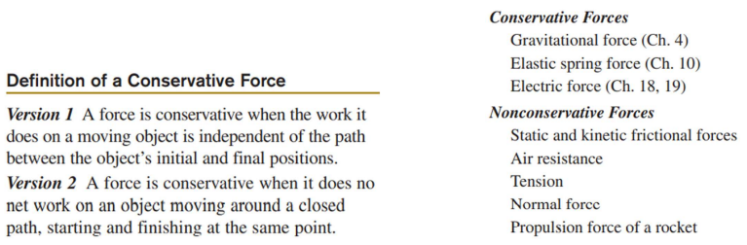

Gravitational force is a conservative force. Work done by Gravity is independent from the path of the motion.
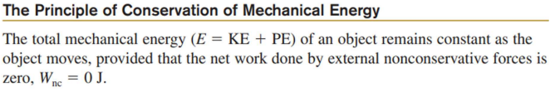
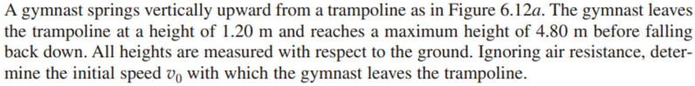

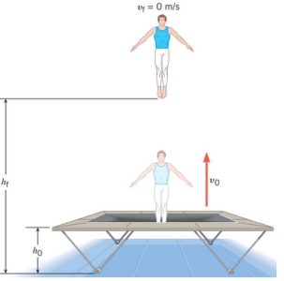
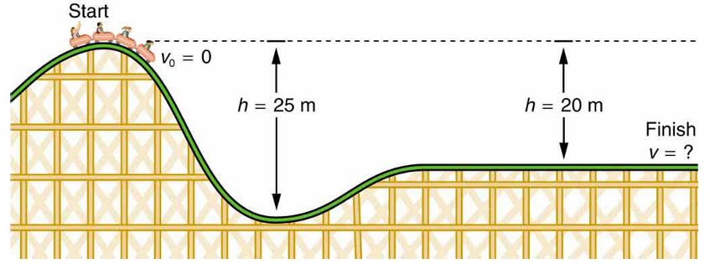
When the roller coaster is moving along the track with negligible friction, is the mechanical energy of the roller coaster conserved? Justify your answer.

(a) What is the final speed of the roller coaster if it starts from rest at the top of 20 m hill with negligible friction? (b) What is its final speed (again ignoring friction) if its initial speed is 5m/s?

Conservation of Energy for the Ideal System

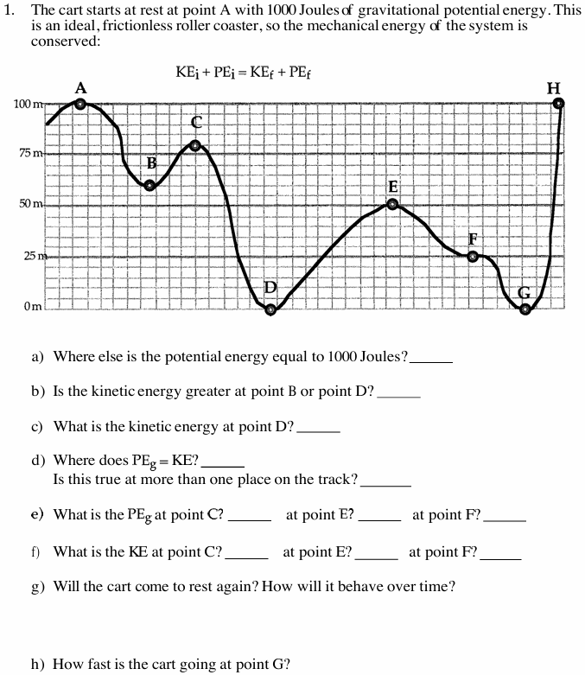

Conservation of Energy for the Ideal System
If non-conservative force does 0 work, then the mechanical energy is conserved:
2.
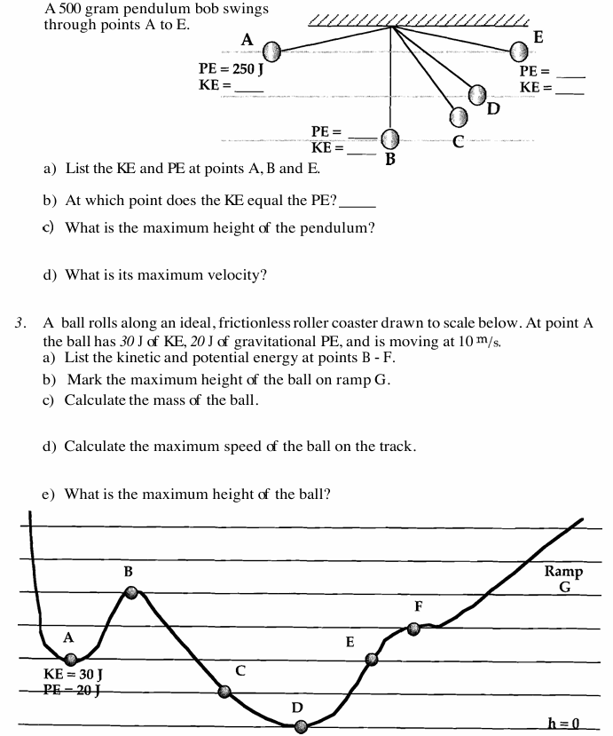

Kinetic Energy and Gravitational Potential Energy
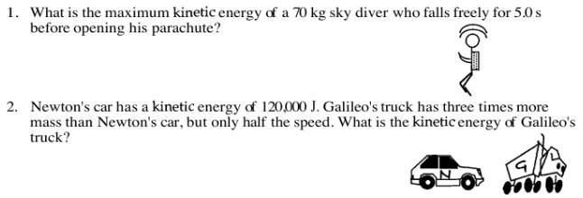

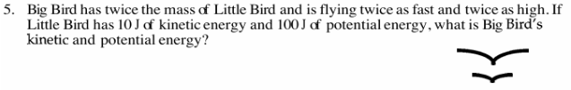

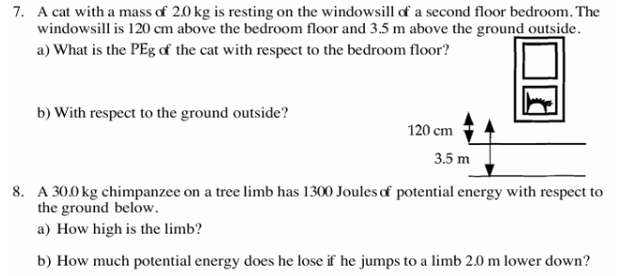

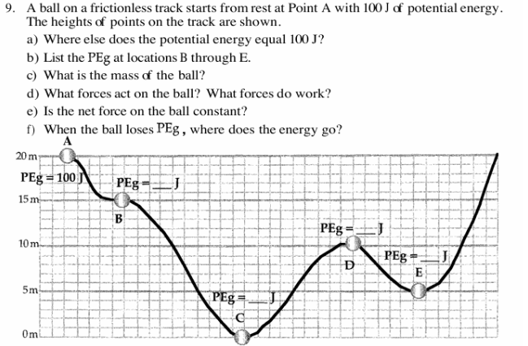
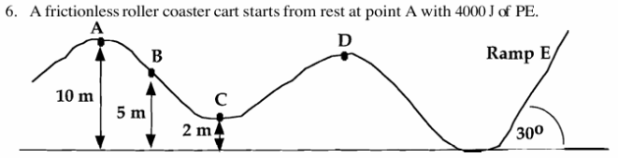
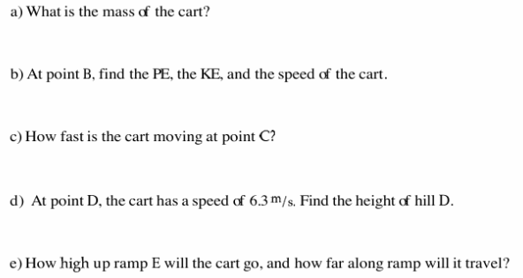
Conservation of Energy Word Problems
